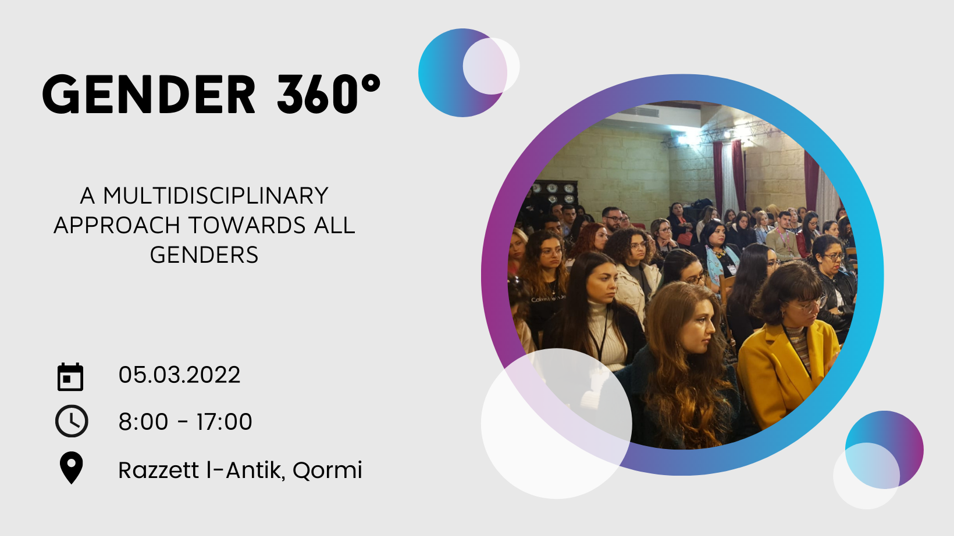
About 360°
The concept of 360° was launched in 2014 in a collaborative effort between Willingness and Betapsi- Psychology Students’ Association as an approach whereby different relevant and current topics are tackled from a multidisciplinary point of view. This means that one issue is discussed from various perspectives of professionals in numerous fields such as psychology, health, social work, youth work, medicine, law, criminology, religion, sociology, philosophy, and various others.
360°’s mission is to create educational and informative events which are not based on one sole perspective, but making use of a multifaceted and interdisciplinary approach. The vision for this approach is to encourage diversity in both knowledge and skill, while gathering a deeper appreciation of other disciplines and the potential advantages in allowing professionals to accommodate larger functional understanding of material and integrated knowledge, instead of working behind isolated perspectives.
As part of 360° we have held, 7 annual conferences, held every March, 6 annual Workshops, held every February at the University of Malta. In 2018 Sex 360° was also taken to Kaunas, Lithuania.
This year we are proud to be bringing, Gender 360° - Multidisciplinary Approach towards all Gender Identities, in Razzett L-Antik, Qormi. This is a hybrid conference where audience can also participate online.

Application Form
The Organising Committee invites authors to submit abstracts for presentation of any theme that is directly relevant to Gender, such as women’s rights, men’s rights, transgender rights, stereotypes, sexuality, family etc. Abstracts are accepted from any profession. The main aim of the seminar is to present the family from a wide range of facets, such as psychological, social, sexual, anthropological, sociological, legal, and medical.
Submissions are sought for Symposia, Workshops and Poster Presentations and can be made via this form.

- Symposia:
Diverse 15-20 minute oral presentations will be grouped in clusters of 3 and then discussed as a group.

- Workshops:
75 minutes long and a mixture of presentation of current literature and group discussion.

- Poster presentation:
Poster presentations will be accepted in academic poster form; presenting research, methodology, and results.

Please note the deadline for abstract submission is 16th January 2022, noon.
Delegates need to fill in and send the application form together with a profile photo to events@willingness.com.mt.

Personal information
Name
Job title
Address
Telephone number
Organisation/Association

Presentation
Title
Aim of presentation
Learning outcomes
References | 1.  2.  3.
Type of presentation | Symposia  Workshop  Poster
Which aspect does the presentation explore? | Medical / psychological / philosophical / physical / legal  other:

Abstract (150 words max.)
Enter text here.

Biography (100 words max.)
Enter text here.

Thank you for your submission. You will hear back from us shortly.

NB. Once application is confirmed as approved by the Organising Committee, should you wish to attend the Conference for the whole day you are to secure place in the Conference by applying and paying the application fee at reduced Delegate price which covers Certification, Coffee Breaks and Lunch.

